Project Design Phase
Solution Architecture

Date | 28 September 2026
Team ID | 6ab227b1fc67a5bc02225fe4
Project Name | UNM110AI_BlogNest
Maximum Marks | 4 Marks

Solution Architecture:
Solution architecture is a complex process – with many sub-processes – that bridges the gap between business problems and technology solutions. Its goals are to:
- Find the best tech solution to solve existing business problems.
- Describe the structure, characteristics, behavior, and other aspects of the software to project stakeholders.
- Define features, development phases, and solution requirements.
- Provide specifications according to which the solution is defined, managed, and delivered.

Example - Solution Architecture Diagram:


Figure 1: Architecture and data flow of the voice patient diary sample application
Reference: https://aws.amazon.com/blogs/industries/voice-applications-in-clinical-research-powered-by-ai-on-aws-part-1-architecture-and-design-considerations/

AI BlogNest — Implemented Logical Architecture
The supplied implementation uses a client–API–database architecture with an external AI service. React/Vite handles presentation and routing; Express exposes REST endpoints; Mongoose persists User and Blog documents in MongoDB; JWT protects authenticated operations; Google Gemini handles generation and summarization.
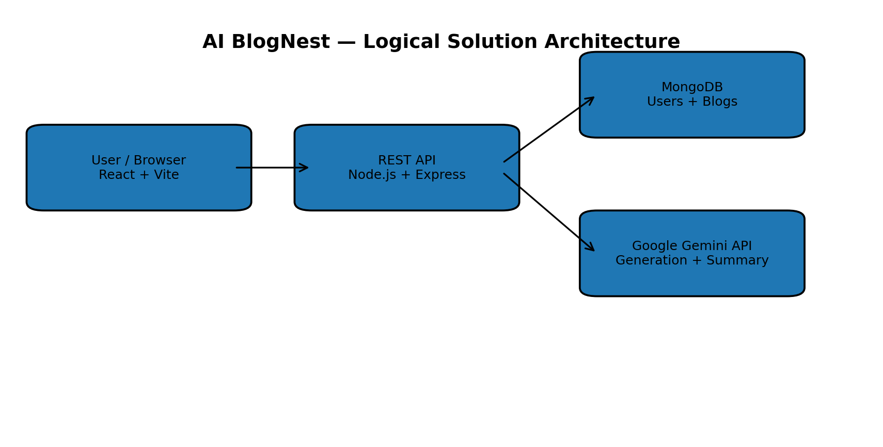
Figure 1: AI BlogNest logical solution architecture
Layer | Component | Responsibility
Presentation | React 18 + Vite | Pages, routing, forms, dashboard, editor, discovery and AI Studio
API | Express REST API | Authentication, blog CRUD and AI endpoints
Security | JWT + bcryptjs | Token authentication, password hashing and protected routes
Validation | express-validator | Input validation
Persistence | MongoDB + Mongoose | User and Blog documents
AI Service | Google Gemini SDK | Blog generation and summarization
Middleware | CORS, Morgan, error middleware | Cross-origin access, request logging and error handling

Primary Data Entities
Entity | Important Fields | Relationship
User | name, email, password, timestamps | One user can author many blogs
Blog | title, content, category, author, authorName, timestamps | Each blog belongs to one user
Public blog listing/detail and summarization do not require JWT in the current routes. Registration/login establish identity; profile, blog creation, editing, deletion and blog generation are protected.

